Fishery Population Dynamics within Profitable Side

Xian Zhou
University of Victoria
CRN22071
Professor Junling Ma
25/04/2022

Introductions
Not only human fishing activities would have effects on the fish population, but also the environmental capacity would influence its populations. On the human side, the harvesting rate and the growth rate are the most influential factors in the fish population. Moreover, supply and demand heavily depends on the economical side. When the price of one object is increased rapidly which surpasses its own exploitation cost, fishmans will barely make any profit, whereas, the distributed area has been contracted due to over-exploitation, which will possibly result in a negative influence on the fish population.
To understand what causes a crash and find out an maximal harvesting rate in equilibrium is a good way to assist the fishmen with choosing the size of the fishing fleet and maximizing the profitability. This report will discuss what would lead to a crash and the equilibrium, then mainly focus on the interaction between fish dynamics and how the profitability works.

Lecture Background Information
In class, a logistic model has been introduced which describes the fish population without harvest. Also the harvested population is in proportion with the population size. N(t) represents population biomass in time t. K is the carrying capacity, r stands for the growth rate.
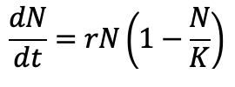

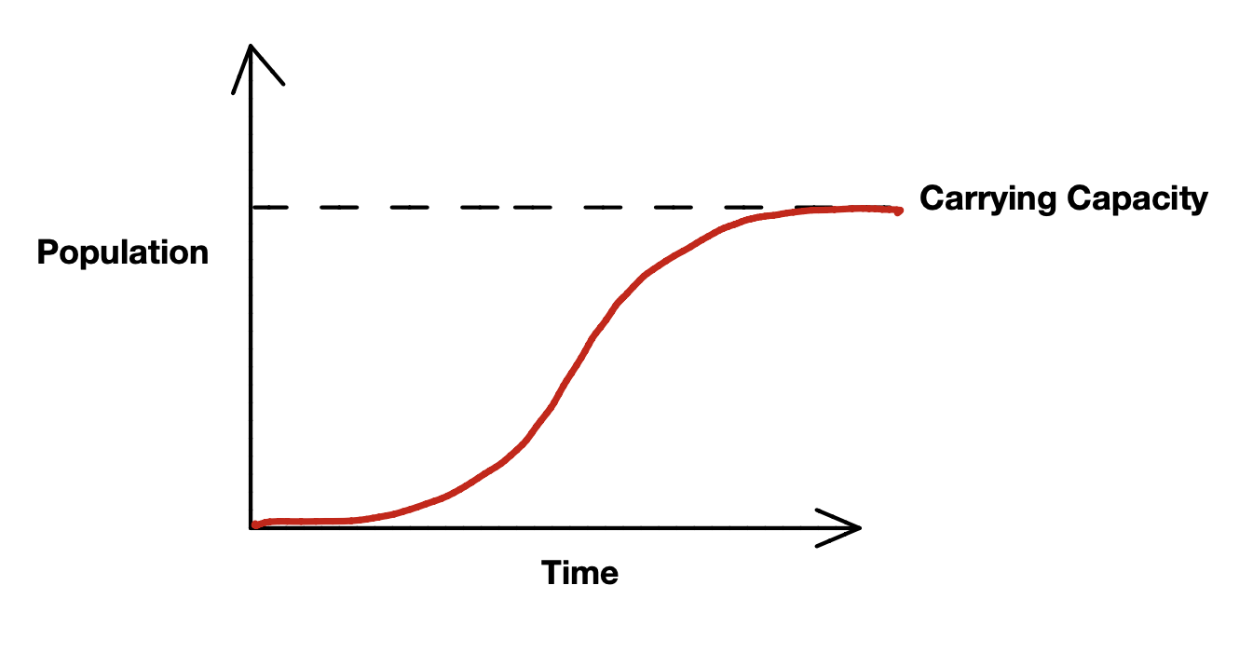
The figure 1 shown below presents a fish population model. Suppose that there is a rare number of young fish inhabiting a pond. At this point, fish are immature and limited, which means the reproduction rate is slow. Also the fish population is not able to rise rapidly. The population increases until fish come to maturity. Later the growth rate will slow down when food and habitat are limited. The death rate will equal the birth rate in the end.
Figure 1. Fish Population Model [1]
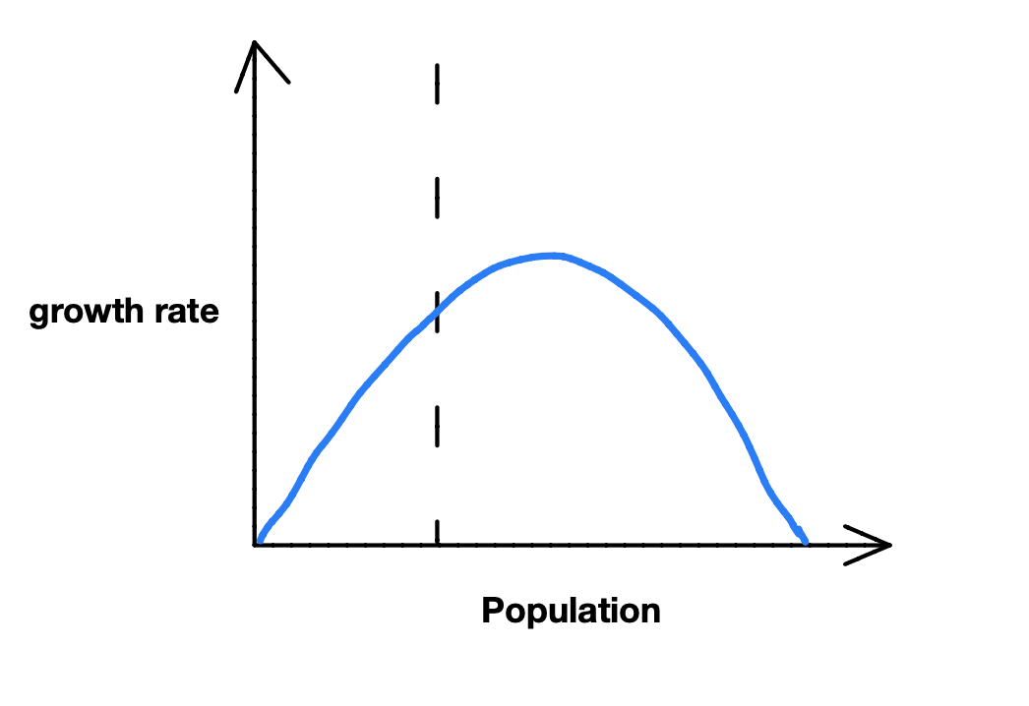
The graph (figure 2) below is a population & growth rate model. Assuming that population is the only factor that affects the growth rate. As population growth follows with reproductive growth. At some point food and habitats are starting to limit growth. Although the reproduction is high, it starts to decline at a negative rate. The growth rate slows until the carrying capacity is reached.
Figure 2. The Fish Population Model [2]
By comparing the two graphs, some facts could be observed. At the beginning in figure 2, as the food and habitats are enriched, the rate of growth rapidly rises as population increases until it reaches the top of the curve. After that, due to the limitation of food and habitats, the rate of growth gradually declines as the population increases. Hence, when the population reaches its capacity, the fish population model is close to horizontal shape as figure 1 shown.

Fishery Harvest Model
From the plot (Figure 2. shown above), the rate of growth of a population is following an exponential path. Assume that r is the growth rate, N is the population in the model. Then, r*N will be the number of the fish that increased, whereas, the whole factor (1−N/K) represents a constraint in exponential growth as the population size N progresses toward.
Therefore, there’s an equation called : Basic Logistic Growth Model:



Where k is the Carrying capacity ,
N is the number of fish,
and r is the growth rate.

After the consideration of the basic logistic growth model, a constant harvesting rate, h , is added for removing a constant number of the fish over a given time interval. To estimate the amount of fish that were harvested, an expression form: multiply h with N.
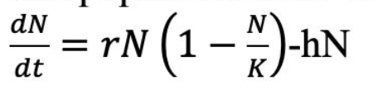
The Fishery Harvesting model becomes:
K : the Carrying capacity , r : the growth rate, N: the number of fish, h : harvest rate.
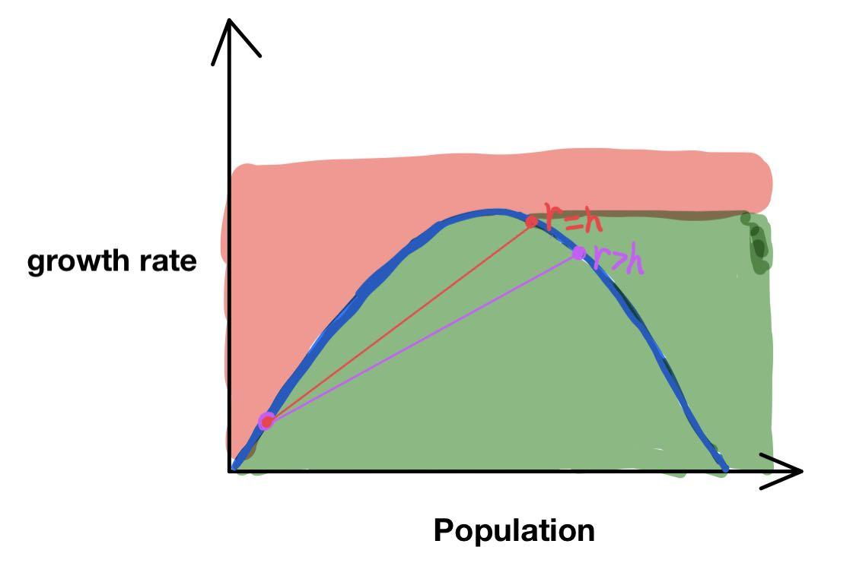
Figure 3. The Harvest Model in Crash and Equilibrium (including r=h, r>h) [3]
Under the Fishery Harvest Model, there are 2 possible outcomes: one is equilibrium, the other one is crash. Crash can be seen as overfishing. If fishmen keep taking away a larger amount of the fish than they can regenerate, the fish population will decline and eventually approach to 0, which is a crash. Otherwise, when the harvest rate is less than or equal to its growth rate, the population would be in an equilibrium.
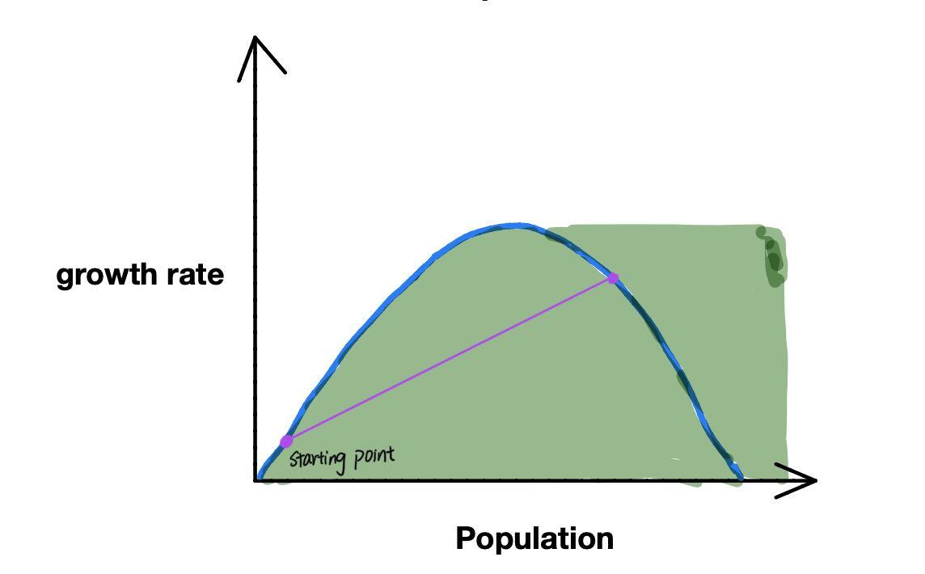
Equilibrium
Figure 4. The Harvest Model in harvesting rate less than growth rate [4]
An equilibrium can only be reached if the rate of extraction is less than the maximum rate. It means that the growth rate always has to be larger than or equal to the harvesting rate. Whenever the growth rate (r) is greater than the harvesting rate (h), there will be more population generated next time. Furthermore, the population will grow exponentially until it reaches its maximum capacity. In this case, if there’s a point starting anywhere on the green part in figure 4 in the condition of r>h. The population will increase with the growth rate, but when it reaches the capacity, the growth rate starts to decrease and the population becomes stable without changing
(The purple line in the figure 4 shows the connection with growth rate and the population changes). Connect the figure 5 with fishery harvest model in class: 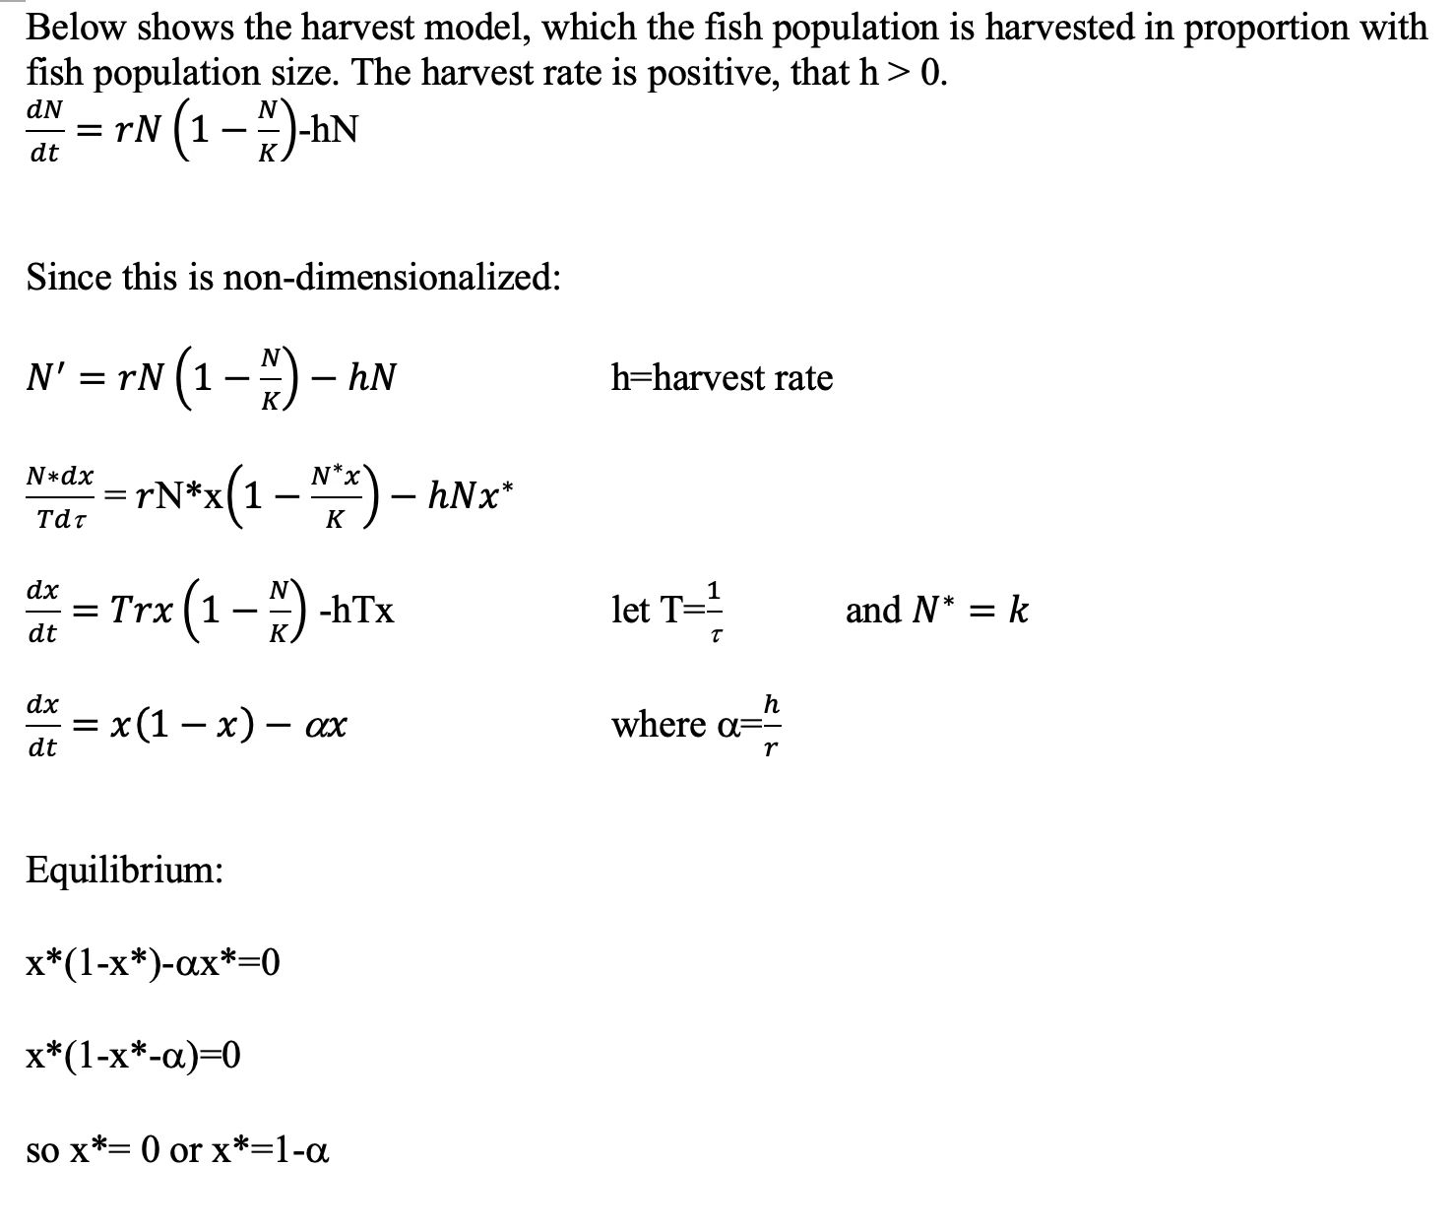
Therefore, The extinction fixed point, x*=0, is unstable for values of r > h . As h increases, the larger equilibrium (carrying capacity) shrinks, but it remains stable for r > h. At a<1, then the function f(x)>0 for x in between 0 and 1-a, there will be an equilibrium.
What is more, with the same rate in growth and harvesting, the population becomes stable. Thus, the growth rate does not change until it reaches the carrying capacity (The red line in the figure 5 below shows relationship of growth rate and population in h=r). To avoid population crash, the harvest rate must be smaller than the growth rate r. The Largest harvest (h) in equilibrium is equal to ax*=a(1-a), which will get a=1/2 with maximum harvest rate =1/4.

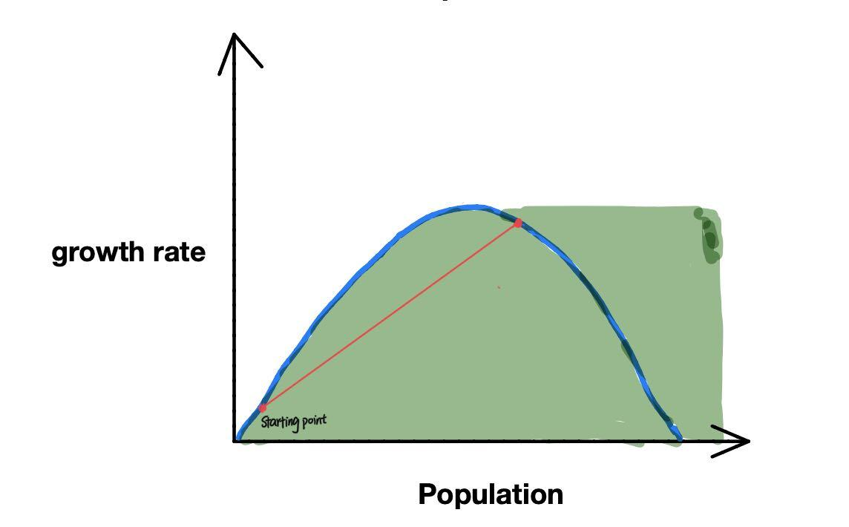

Figure 5. The Harvest Model in Harvesting Rate and Growth Rate are Equal [5].

Crash
Based on the fishery harvest model in class, when alpha is larger than 1, all x>0 will result in a f(x)<0. As alpha equals harvest rate divided by growth rate, r will be smaller than h. In explanation, it means the growth rate r is smaller than the harvest rate h.
From the red section of the harvest model, if the amount of fish is taken in this red area, there will result in the harvest rate larger than the growth rate. Fish are not able to reproduce in limited time. The situation of overfishing will result in a decline of the fish population. If fishing keeps taking in those red areas, this might come up with a fish population collapse.

The Relationship between Profitability and Sustainability
To achieve economic efficiency, it is necessary to search for the maximum sustainability and maximum profit. Suppose that the profit is the maximum value of the difference between the total revenue and total cost. For the variable cost, which is related to the fishing effort. Assume that for every annual effort, the cost of producing fishing effort remains the same. For the variable revenue, which is related to the price of fish. Suppose that the price of fish in tons is fixed, which indicates that the revenue is only determined by the number of fish population.
Furthermore, the maximum sustainability includes two factors, one is fishing effort and the other one is sustainability.
As the fish population decreases, more effort is required to catch the fish. That is, the more effort we put in the fish, the lower the population will be. At the beginning, when the population is at carrying capacity, the equilibrium catch is zero. As we put in more effort, we keep freeing up a room for the fish and the growth rate increases until it reaches the point named maximum sustainable yield as shown in figure 6. At this point, the population is still limiting a little bit of the growth but after this point, the population is lower and there is less fish reproducing, which is the limiting growth and then this condition continues until there is no more fish to reproduce. At Maximum economic yield point, the amount of effort where the profit is maximized and the catch will be sustainable. However, the maximum economic yield point will be at lower fish catch than the maximum sustainable yield.

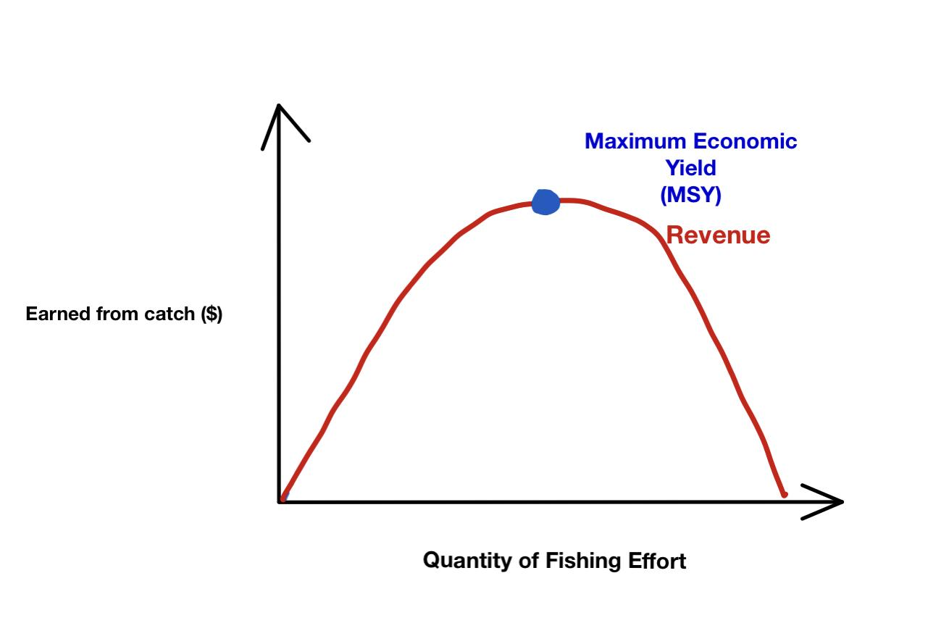
Figure 6. [6]

Based on the figure 7, the green line represents the same slope with the line cost so the maximum profit will be the difference between green line and line cost. Besides, the point of intersection with the green line and revenue curve will provide us with the ideal size of the fishing fleet. However, the profit will decrease as the size of fishing effort increases as demonstrated with the light green line, eventually which will approach a point called positive equilibrium point. The more fishing effort, the less profit will result in as the light green line shifts right to the red line. The blue point shows the intercept of cost to revenue. Range under the red line will lead to the cost bigger than revenue which means there is no more profit to be made for fisher. There is no longer for the fisherman to increase the size of the fishing fleet (the level of effort).
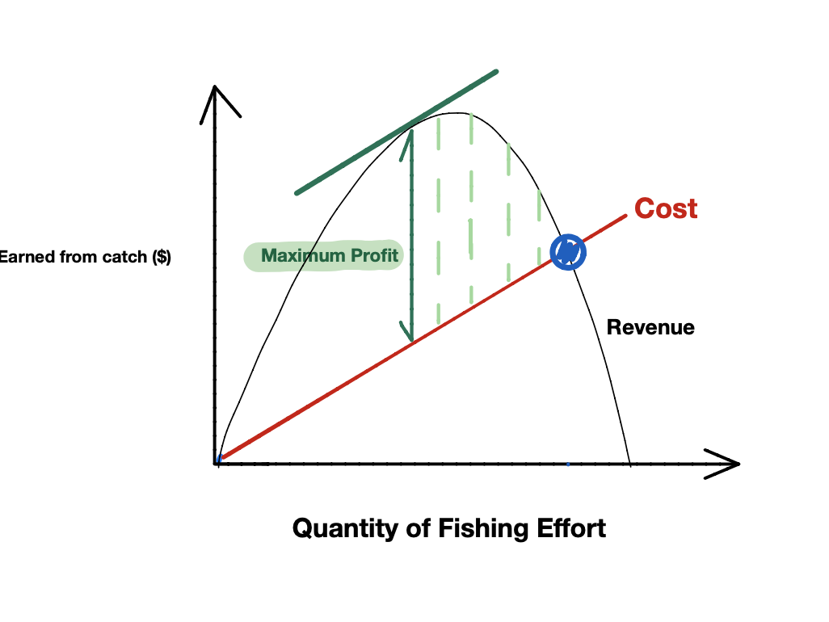
Figure 7. [7]

Conclusions
Based on the information above, there are three points in this figure 8. The green point shows the maximum economic yield which gives maximum profit to fisher and its corresponding size of the fishing fleets. At this point, the fishermen are able to earn the most. The yellow point at the peak of the quadratic function is the maximum sustainable yield. Fishing at this profit is environmentally-friendly to the sustainability of fish population growth. The blue point on the linear line and the quadratic function illustrates the equilibrium. In the equilibrium, there are maximum fishing fleets with minimum profit approximate to zero. After that point, fishermen can not make any profit as there is no more fish to catch.

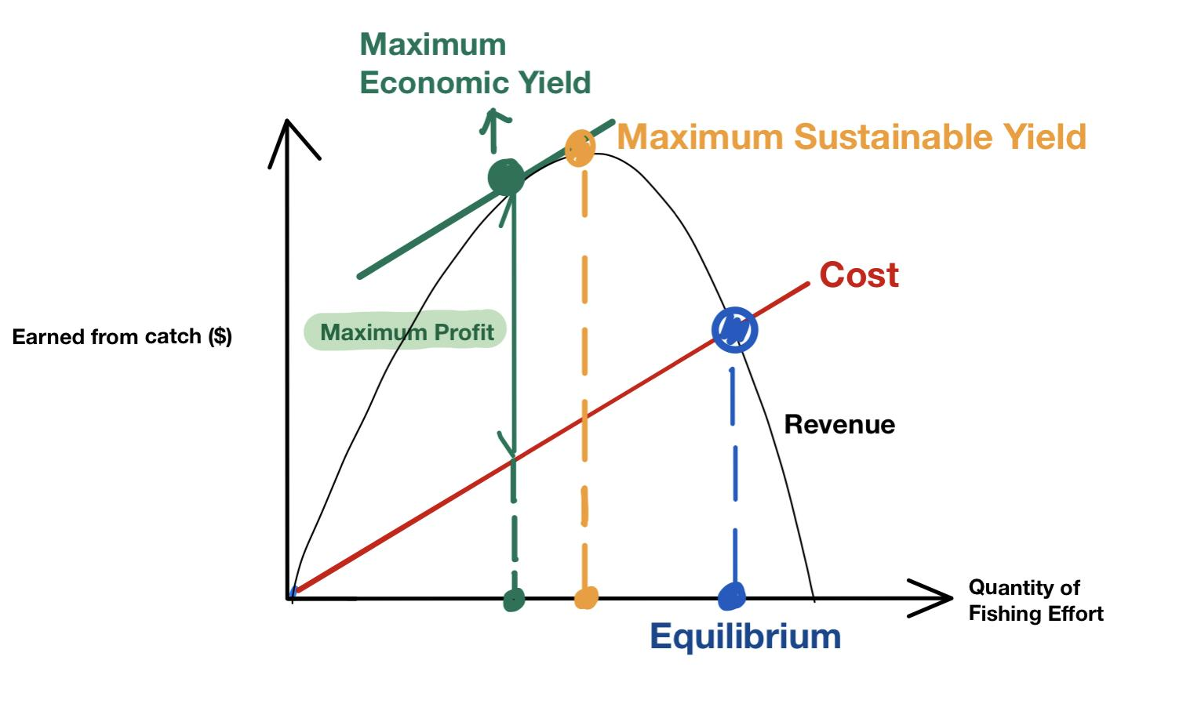

Figure 8. [8]

